**Super Simple Summary of Snowflake Architecture**

Snowflake has **three layers** that work together to handle data **efficiently** and **cost-effectively**.

1️ **Storage (Elastic Storage)** – Where data is **saved** (like a big digital warehouse).

* You can store **any amount** of data, from small to huge.
* Storage is **separate from computing**, so you can **grow storage** without worrying about processing power.
* **Automatic backups** keep data safe.

2️ **Compute (Elastic Compute)** – The power that **processes** your data.

* Runs **fast queries** and allows **multiple users** at the same time.
* Can be **scaled up or down** depending on your needs (pay only for what you use).
* **No need to copy data** when making clones, saving storage space.

3️ **Integration (Bringing It All Together)** – Storage & Compute work **seamlessly**.

* Adjust **storage** and **compute power** as needed.
* **Smooth experience** for any company size.

**Example:**

Think of Snowflake like a **restaurant**:

* **Storage = The Kitchen Pantry** 🍞 (All the ingredients are stored here, and you can add more shelves when needed).
* **Compute = The Chefs & Cooking** 👨‍🍳 (You can hire more chefs at busy hours and reduce staff when it's slow).
* **Integration = The Restaurant Experience** 🍽️ (Everything works smoothly so customers get their food quickly and efficiently).

This setup makes **Snowflake powerful, flexible, and cost-effective**! 🚀

# **SCREENSHOTS**

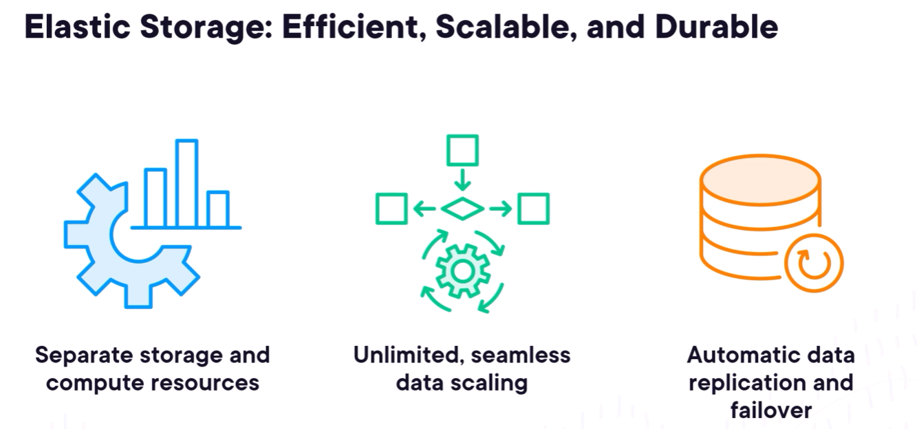

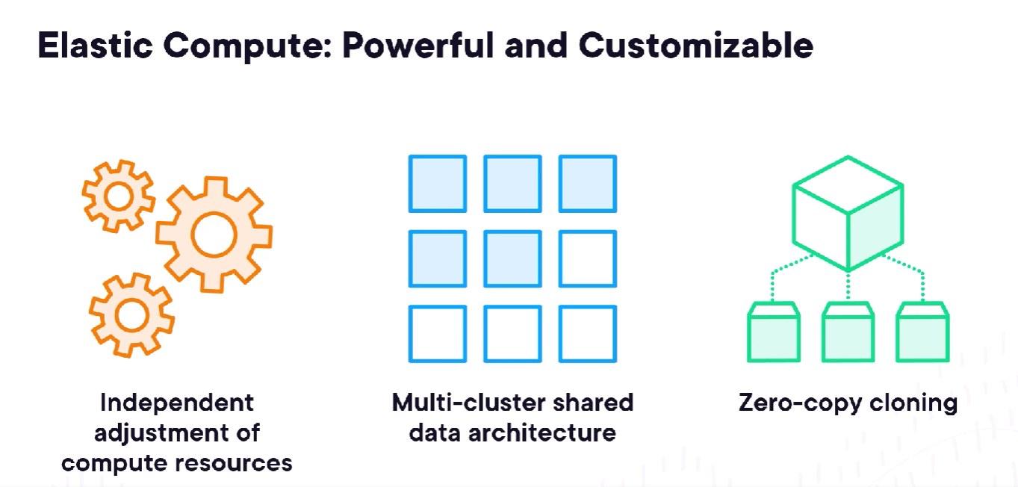

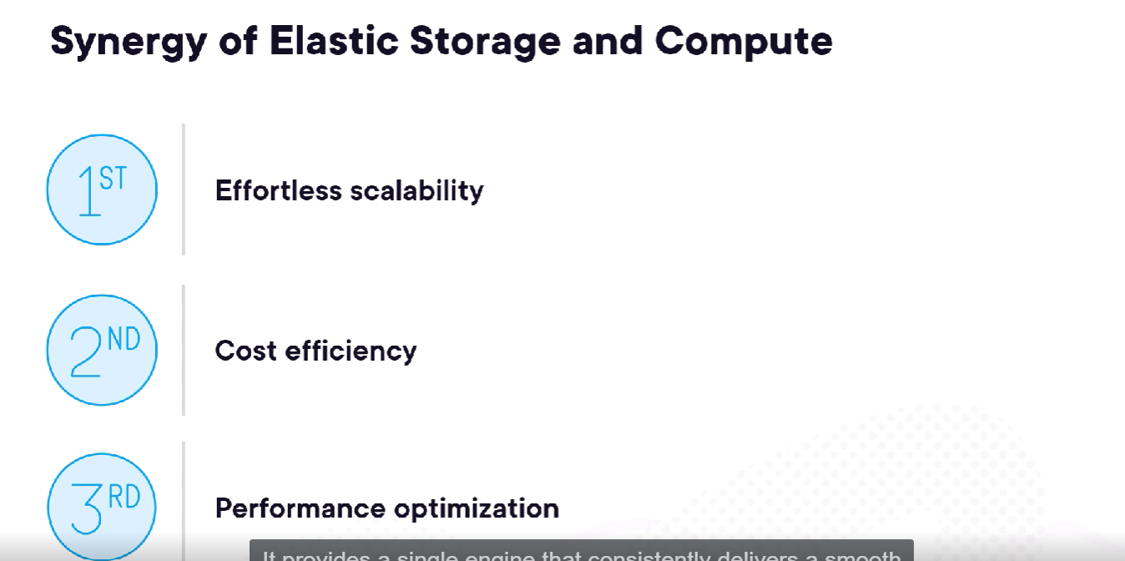

**Effortless scalability** refers to the ability of a system, platform, or infrastructure to automatically adjust its resources (such as computing power, storage, or bandwidth) based on demand, without requiring manual intervention.